Atmel AVR 2004 Design Contest Project No: A3810

AVCX – Color TFT LCD Controller

General Description

The Figure 1 shows the block diagram of the controller, which drives the ACX705AKM 512 colors 240x160 TFT LCD display by Sony. The device has been called “AVCX” (AVR + ACX705AKM ).

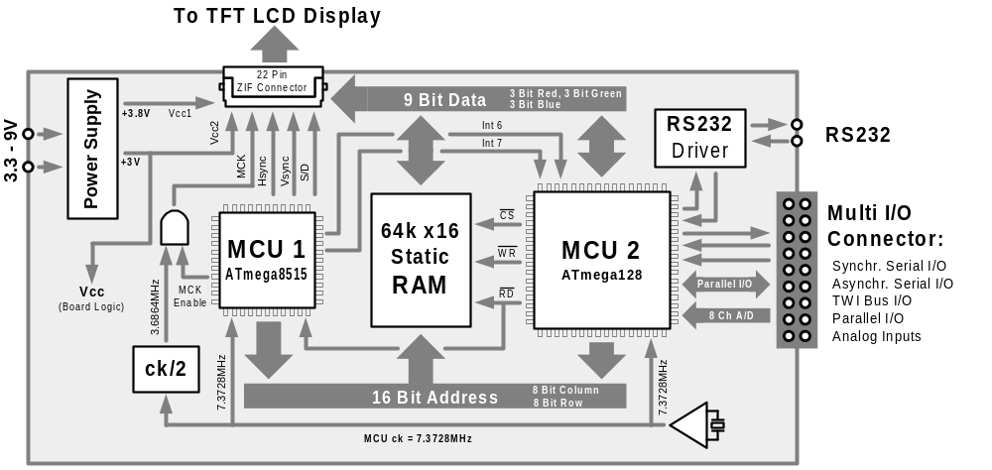Figure 1 Block Diagram

AVCX uses two AVR chips to control the LCD: MCU1 (Atmega8515) and MCU2 (Atmega128). Both micro controllers share the Static RAM, which is used as the Video RAM.
MCU1 pick-ups the color pixel data from the Static RAM and controls the LCD by generating the following "digital CRT" video signals:
- MCK (dot clock)
- Hsync (horizontal synchronization)
- Vsync (vertical synchronization)
- 9 bit RGB (3 bit Red + 3 bit Green + 3 bit Blue)
- S/D (shutdown)
With each pulse of the dot clock, MCU1 addresses Static RAM with the new 16-bit address, which is used to retrieve the 9 bit RGB data.

MCU2 interprets graphic commands (received through RS232, or any other interfaces) and stores the resulting pixels in the shared Static RAM, where they are picked-up one by one by MCU1 and sent to the LCD as described above.
Video RAM Access Arbitration

Since Dual-Port RAM chip is quite expensive, AVCX uses standard, Single-Port 64kx16 Static RAM (CY7C1021). MCU1 reads pixel data from RAM during active video periods, while MCU2 writes to RAM during synchronization periods. The Figure 2 shows the horizontal timing chart.

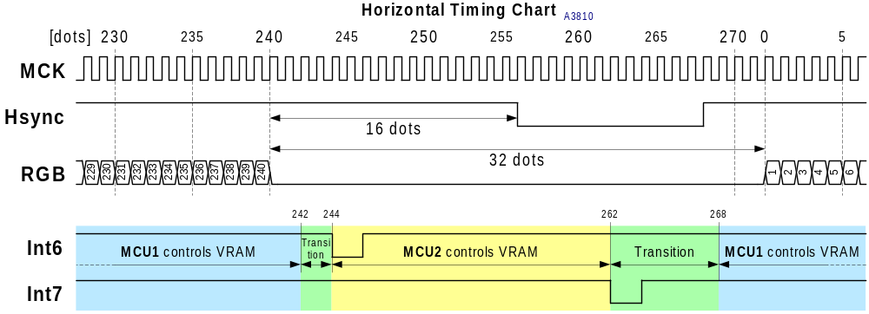
Figure 2 Horizontal Timing

- MCU1 has exclusive RAM access during active video periods (dots 1 to 240)
- On the dot 242 MCU1 releases the control of RAM, and then triggers MCU2 Interrupt 6
- MCU2 jumps into the Interrupt 6 service, where it accesses the RAM
- On the dot 262 MCU1 triggers MCU Interrupt 7
- MCU2 jumps into the Interrupt 7 service, where it releases the control of RAM
- MCU1 waits until dot 268 and then takes back the control over RAM

The Figure 3 shows the vertical timing chart. In this case MCU2 gains access to the Video RAM for the whole 40 lines (40*272 = 10880 dots).

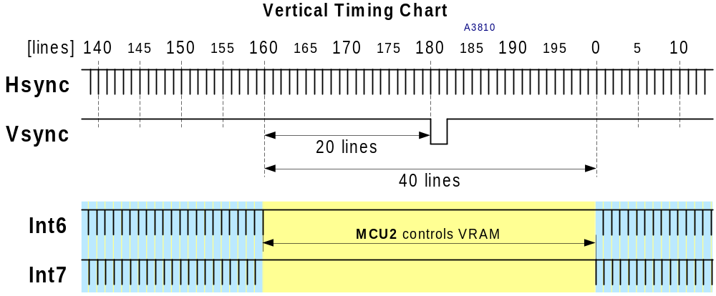
Figure 3 Vertical Timing

